BRAC University
Department of Computer Science and Engineering

Spring – 2007
CSE110 (Programming Language-I )
Lab 5

1.Write a y program that will calculate the value of y if the expression of y is as follows (n is the input):

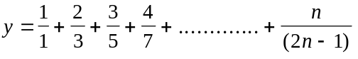

2. Write a Java program that will calculate the value of y if the expression of y is as follows (n is the input):

3. Suppose the following expressions are used to calculate the values of L for different values of S:

L = 
L = 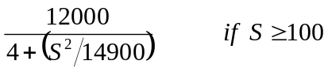

Write a Java program that reads a value of S and then calculates the value of L.

4. Write a Java program to compute and display a person’s weekly salary as determined by the following conditions:
If the hours worked are less than or equal to 40, the person receives Tk200.00 per hour, else the person receives Tk8000.00 plus Tk300.00 for each hour worked over 40 hours.
The program should request the hours worked as input and should display the salary as output.

5. Write a Java program that performs four functions of a calculator. The program should request the user to enter a floating-point number, an operator and another floating-point number. It should then carry out the specified arithmetical operation: adding, subtracting, multiplying, or dividing the two floating-point numbers. Finally, it should display the result.

